

ASIA PACIFIC COLLEGE

School of Computing and Information Technologies

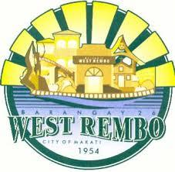

**“COMMUNITECH”**

**Rhudolf Valentin Flores Mr. Manuel Sebastian Sanchez**

Project Manager Project Consultant

**Celyn Jarilla Mr. Noel Anonas**

**Ma.Antonette Laming** Project Advisor

Project Developers

1. Executive Summary

Barangay West Rembo is located in the Second District of Makati has a total of 28, 406 population. With its growing population and a wide land area the major concern of Barangay West Rembo is that there are no concrete forms of announcing schedules for trash collection within the Barangay. The residents don’t know the time of arrival of the garbage truck and they don’t want their garbage so they dispose it in an unordered way. The improper disposal of trash may lead to other forms of problem. Another problem of the Barangay is that certain announcements may not reach some places within a specific time because the Barangay is actually huge. Other complaints may be also be far from the Barangay Hall that is why some complainants need to travel first before stating such complaint.

Implementing the project “COMMUNITECH” will be a tool to help the barangay council to disseminate information to the barangay residents. The users can also send an incident report, their concern and complaints using “COMMUNITECH”.

The project “COMMUNITECH” would also feature where and when the arrival of the garbage truck and the proper disposal.

1. Introduction

* **Project Context**

Barangay West Rembo is located in the Second District of Makati and situated at the North East Cluster along with Cembo, Northside and Guadalupe Viejo.Based on the 2010 Census of Population conducted by the National Statistics Office, West Rembo has a total of 28, 406 population and percentage share of 5.4% versus the city’s population with an estimate of at least 5,681 households. By population density, on the other hand, considering its land area and population count, the barangay has 52 person per square meters.

This barangay has a total land area of 0.552 square kilometer and predominantly residential. Barangay West Rembo is known to house several institutional lots such as the Makati Parks and Garden and University of Makati.

* **Purpose and Description**

In this modern generation, everyone is almost technologically adept and generally, almost everything involves the use of a computer or a mobile device.

The group will develop a project “COMMUNITECH” that would benefit the Barangay Constituents of West Rembo. The group would use this as an opportunity to come up with an easier method of disseminating information and reporting complaint and concerns from the residents.

1. Objectives

The objective of this project aims to disseminate information effectively and efficiently throughout Barangay constituents and for them to send an incident report about their concerns and complaint by the use of android application information system.

* + - * To provide the client an android application information system.
      * To make it easier for the Barangay Council to announce updates, and news to the residents of the barangay.
      * To manage proper waste management within the barangay based on the android application.

1. Scope and Limitations

The group aims to disseminate information easier and efficiently by providing an instrument that allows the user to send a report and their concern and complaint. The project “COMMUNITECH” is a mobile application that would serve as the said instrument. The project “COMMUNITECH” would provide user announcements and news and will be able to send a complaint and concern report. The project would also provide a mobile map that will help them to locate the garbage truck and where to dispose their waste.

|  |  |
| --- | --- |
| Features |  |
| Announcement and News | Provides user information |
| Garbage Truck Locator | Provides user the schedule of the garbage truck |
| Complaint and Concern | Allows user to send an incident report |

* Scope of Initial Release

The initial release is essential for the application. It will show what the application can do for the people. The application will include the feature where it can show the trash collection schedule, the user can send complaints and can view the announcements made by the Barangay. Also, information about the Barangay itself will be available for the people who need the information.

* Scope of Subsequent Releases

As time goes on, the application may also provide the current location of the garbage truck in order to easily know the path of the collection. The application may also add a feature where you can add photos as back-up evidence on your complaints.

* Limitation and Exclusion

The study aims to disseminate information and transactions within the constituents of Barangay West Rembo more efficient, easier and hassle free by the use of Web and Mobile application system. The system scope is to perform certain task; to cater management of information and transaction about the events, announcement and upcoming projects of barangay, waste management and the user can send a text message complaint report, the complaint report will be directed through the admin or officials of the Barangay West Rembo.

The application will not be handling the processes of the barangay itself. You can just submit forms using the app but you need to go to the Barangay in order to claim your things. The application will also not be handling registration in certain projects like “Ligas”, “Scholarships” and many more. You can just check the requirements using the app for those certain projects but need to go to the Barangay to register.

1. Related Literature/System

Barangay Information System: A Tool for Local Planning and Project Implementation

By: Baltazar, Eugenia G., Lazaro, Serafin C., Paderes, Aurora S., Ponce, Ardenn R., Central Luzon State University

The project is an action-research designed to come up with a model for enabling barangays to establish and maintain a Barangay Information System (BIS) for rural development planning and implementation. Specifically, the study aimed at: (a) providing a profile of LGU officials in the barangay, (b) determining the barangay leaders' knowledge of and perception about the barangay hall as a base for BIS; (c) finding out the existing information systems in the barangay; (d) documenting the process involved is establishing and maintaining a BIS; (e) identifying the facilitating and hindering factors in the barangay's establishment of BIS; and (f) drawing up a model and other recommendations that may guide in the future implementation and replication of BIS. Results revealed that majority of the respondents perceived their barangay hall as very useful in terms of serving as venue for meetings and as source of vital information about the barangay and its people. However, they felt the information is inadequate to be basis for planning and in responding to information request from local government offices. They also felt there is still a need to improve its surroundings and provide facilities like chairs, tables, cabinets and enrich the information available in the place. As regards BIS implementation process of the nine barangays, there were commonalities among the barangays in following a basic implementation process from orientation meeting to data storage and updating. However, there were also observed peculiarities on data gathering techniques and logistics wherein some barangay officials voluntarily use their own money for supplies and materials and even provided snacks for BISD Team members during data gathering, data posting/tabulation and data presentation so the activities will not be delayed. The local officials' educational attainment and training were the factors that contributed to early completion of BIS activities in some barangays while the observed hindering factors were the change in political leadership; lack of logistics; geographical dispersion of houses and number of households; socio-economic preoccupations of household respondents and BIS team members; and turn-over of BIS team members as a result of the local elections held in 1997. The following recommendations were given: barangays should allocate budget for BIS activities, training opportunities should be provided to local leaders and inter-barangay visitation of BIS team members should be conducted for them to share and learn from each others experiences.

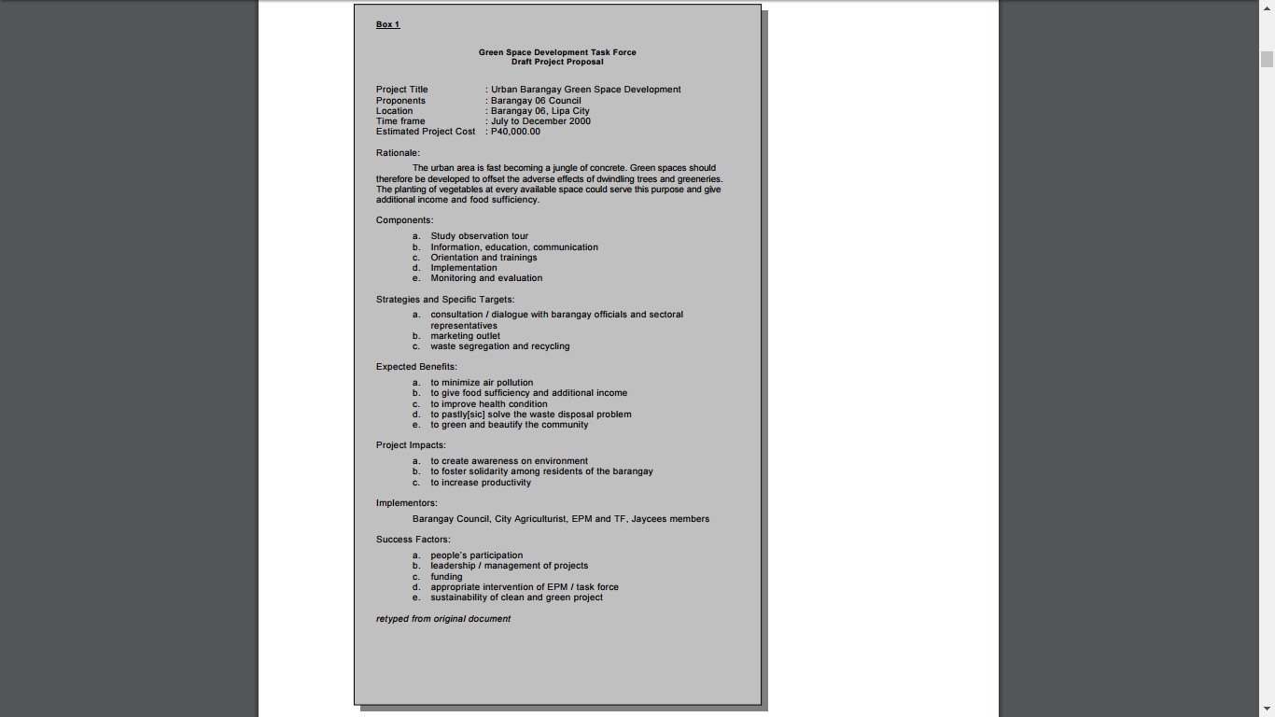

1. Technical Background

|  |  |
| --- | --- |
| **Mobile Application** | |
| **Features** | **COMMUNITECH** |
| **Announcement and News** | Text based sent from website through smartphones |
| **Complaint and concern** | Text based sent to website database |
| **Garbage Truck Locator** | Text based sent to website database |

The project “COMMUNITECH” is designed to be deployed through smartphones, the group used Java Language on Eclipse Luna And SDK Tools for developing the part of the project’s mobile application.

As for the website, the group used PHP as the programming language used and for the developing tools we used Notepad

1. Business Requirements

The major concern of Barangay West Rembo is that there are no concrete forms of announcing schedules for trash collection within the Barangay. The residents don’t know the time of arrival of the garbage truck and they don’t want their garbage so they dispose it in an unordered way. The improper disposal of trash may lead to other forms of problem. Another problem of the Barangay is that certain announcements may not reach some places within a specific time because the Barangay is actually huge. Other complaints may be also be far from the Barangay Hall that is why some complainants need to travel first before stating such complaint.

1. Background

Due to the reason that people are actually complaining about not having some concrete way of delivering certain announcements to the people, we find the application very useful for the residents of the Barangay having the information they need at the comfort of their homes.

1. Business Opportunity

We may say that there are not much barangay-based application and a Barangay is actually the smallest form of government, the application may be useful in order to maintain such order within a small community that someday can be widen through the use of developing the application for a bigger crowd.

1. Business Objectives and Success Criteria

The Barangay can have an easier way of organizing the complaints made and with just the right time, a certain complaint may already have an action just after sending it. The Barangay can easily spread announcements with just a click of a button using the application. The information given to the public can be easily spread by the Barangay using the application.

1. Customer or Market Needs

The application can be made user-friendly in order for users to easily understand the use of the application and how it would work. The updates of every announcements made by the Barangay may be seen by a user even if s/he is far from the Barangay Hall because of the application. Residents can also track the schedule of the trash collection that may prevent them from disposing their garbage at the wrong time.

1. Business Risks

Some of the risk that can be taken in consideration is that the Barangay may contain people who don’t own any android/apple devices. Even the budget for the implementation of the application may also be a risk because the other projects may be the priority for the money.

1. Vision of the Solution

We envision an application that is user-friendly, can be easily access and very efficient. We are looking forward to a future that has peace and order, which can be a better place to live in. We envision a community that is more organize and can communicate well with each neighbor. It is the people that drive us to create an application for their comfort for each and every one of us deserves better service.

1. Vision Statement

The application can be an opportunity for other barangay-based application ideas to be brought to life. It is like the beginning of a new era. We slowly embrace technology as the society grew. The application can be a new way of communication between the Barangay and its’ residents. This is a major step in creating a nation where the action may take place as soon as possible for the processing time can be shorten by the application and the way of disseminating information is fast and efficient.

1. Major Features

1. Shows updates of trash collection schedule – In this feature show the date, time and starting point of the collection of garbage. With this, residents will know when to take out their garbage from their houses to avoid pile of garbage in certain locations.

2. Let users to send complaints – In this feature, the user is allowed to send complaints that are related to their community like clogged drainage, fallen tree, etc.

3. Shows all announcements made by the Barangay – In this feature show all announcements that are made by the Barangay or anything that the residents will benefit from.

1. Assumptions and Dependencies

A third-party is necessary for the implementation of the application for the Barangay may not be able to handle the servers for the application. The residents also need to obtain an android device in order to use the application.

1. Scope and Limitations

The application will not be handling the processes of the barangay itself. You can just submit forms using the app but you need to go to the Barangay in order to claim your things. The application will also not be handling registration in certain projects like “Ligas”, “Scholarships” and many more. You can just check the requirements using the app for those certain projects but need to go to the Barangay to register.

1. Scope of Initial Release

The initial release is essential for the application. It will show what the application can do for the people. The application will include the feature where it can show the trash collection schedule, the user can send complaints and can view the announcements made by the Barangay. Also, information about the Barangay itself will be available for the people who need the information.

1. Scope of Subsequent Releases

As time goes on, the application may also provide the current location of the garbage truck in order to easily know the path of the collection. The application may also add a feature where you can add photos as back-up evidence on your complaints.

1. Limitations and Exclusions

The study aims to disseminate information and transactions within the constituents of Barangay West Rembo more efficient,easier and hassle free by the use of Web and Mobile application system. The system scope is to perform certain task; to cater management of information and transaction about the events,announcement and upcoming projects of barangay, waste management and the user can send a text message complaint report, the complaint report will be directed through the admin or officials of the Barangay West Rembo.

The application will not be handling the processes of the barangay itself. You can just submit forms using the app but you need to go to the Barangay in order to claim your things. The application will also not be handling registration in certain projects like “Ligas”, “Scholarships” and many more. You can just check the requirements using the app for those certain projects but need to go to the Barangay to register.

Business Context

Stakeholder Profiles

> Project Priorities

## Operating Environment

Purpose, Scope, and Objectives

**Scope**

System Overview

Contacts

Project manager – rhudolf flores

Project analyst – celyn jarilla 09275509820/ [celynjarilla@yahoo.com](mailto:celynjarilla@yahoo.com)

Project developer – Ma. Antonette laming

Project References

• aDAMS(Barangay Database Management System

• MyLA311 Android and IOS App

• Brgy. Bangkal PhilHealth Center - Database System

• In hand Barangay Pinagkaisahan

Relationship to Other Projects

Organizational Interfaces

## Acronyms and Abbreviation

Planned Activities, Events, and Deliverable

Roles and Responsibilities

## Methods and Techniques

## 

## Environment

**Methodology Results and Discussion**

**4.1 Requirements Analysis**

**4.2 Requirements Documentation**

**System requirement:**

Api 17

Windows 7 up

**Hardware requirement:**

**Software requirement:**

Notepad++

Adobe Photoshop

Eclipse Luna

Xampp

Mysql Workbench

Rational Rose

Draw.io

Visual Paradigm



